ANNFAM FOUNDATION

- Vision Statement:

We envision a world where the less endowed and the vulnerable in the society are given equal opportunities to unearth their full God given potential

Our foundation envisions a world where the gap between the less endowed and the privileged is bridged. We believe that every individual deserves access to basic needs such as education, healthcare and food. Our goal is to empower the vulnerable and the less privileged in the society by providing them with the necessary tools and resources to improve their lives.

Through our programs and initiatives, we aim to create equal opportunities for all individuals regardless of their socio-economic status. We envision a world where everyone has the chance to reach their full potential and pursue their dreams. Our foundation is committed to making a positive impact on the world and ending the cycle of poverty.

2. Mission Statement:

Our foundation is committed to bridging the gap between the less endowed and the privileged members of our society. We believe that every person deserves access to basic necessities in life, education, healthcare and other essential services, regardless of their socioeconomic background.

Through our various programs and initiatives, we would strive to create a more equitable and just society, where everyone has the opportunity to reach their full potential. We would work towards building strong partnerships with other organizations, businesses, and government agencies to ensure that our efforts are sustainable and impactful.

Our mission is to empower individuals and communities, promote social justice, and address systemic inequalities. We are dedicated to creating lasting change and improving the lives of all people, especially those who have been historically marginalized and excluded.
Together, we can build a brighter future for all.

3. Long-Term Strategic Objectives

3.1 Increase funding and partnerships: Over the next five years, the foundation's main focus will be to increase funding for scholarships and other support initiatives through donations and establishing partnerships with other organizations to maximize the impact of its programs.

3.2 Expand educational programs: To achieve its mission of providing high-quality education to underprivileged children, the foundation plans to expand its educational programs to more regions in the country, with a special focus on remote and rural areas.
3.3 Strengthen community outreach: In order to ensure that the foundation's programs are benefiting the most vulnerable members of society, it will strengthen its community outreach efforts and actively involve local stakeholders in program planning and implementation.

3.4 Enhance organizational capacity: The foundation will invest in its organizational capacity by hiring more staff and experts to manage and oversee its programs, and by improving its infrastructure and processes to ensure smooth program execution.

3.5 Develop monitoring and evaluation systems: To measure the impact of its programs and ensure accountability and transparency, the foundation will develop robust monitoring and evaluation systems that track program outcomes, outputs, and impact.

6. Our Core Values
- Integrity
- Dignity And Respect
- Collaboration
- Service

7. Key Focus Areas
- Education
- Mental Health Support
- Vocational Training
- Youth Counseling
- Small Business Support
- Scholarship
- Child Health Support
- Prison Ministry

ORGANIZATION

- Board Of Directors:

- Board Chairman - Mr. Thomas Kwaw Annan
- Mercy Annan (Mrs) - Board Member
- Chief Executive Officer (CEO) – Miss Esther Ehu Annan
- Director In Charge Of IT & Systems - Mr. Richard Kofi Annan
- Director in Charge of Human Resource and Corporate Relations – Miss Lydia Tayibah Annan
- Organizing Secretary – Miss Rebecca Akesi Annan
- Director Of Operations – Mr. Joshua Kojo Annan
- Director Of Finance – Mr. Godson Kofi Amanfo
- Director - Administration/External Relations - Sylvia Annan (Mrs)
- Patrons - Mr. Frederick Botchwey.

Source Of Income: Internally Generated Funds (IGF)

Activities Planned for Quarter 3 & 4 2023

We planned to have three activities the for the last quarter of the year 2023

- First activity scheduled for - 19th or 20th September (A cash donation to the Holy Trinity School, Boete - Obuasi to provide school fees support to the brilliant but needy students at the school)

- Third activity scheduled for 20th December 2023 - Donation to Patmos Orphanage to commemorate the 61st birthday of the Board Chairman

- Christmas Party for orphans at Patmos Orphanage

2024 Programmes

- Launch AnnFam Foundation - 1st Quarter 2024
- Health Screening in collaboration with Estel Pharmacy and Anglogold Ashanti Health Foundation (AGAHF) ***(April / May 2024)
- Scholarship Awards - 1 x Tertiary student, 1 x SHS student (January 2024)
- Setup ICT Laboratory to be called ‘Master Danso ICT Laboratory’ for the school in honour of the ‘angel of my life’
- Planned Collaboration/Other activities with Kuffour Scholars Program (KSP) , Youth Arise Organization (YAO)*** and other partners

THE ANNFAM STORY

The central figure in the AnnFam story is the Late Mr Danso aka Master Danso. This looks weird at the first glance considering the fact that this noble personality is not part of the Annan Family. How then, do we describe him as the central figure in our story?
The late Mr Michael Kwabena Danso, aka Master Danso was the Headmaster of St. Joseph’s Middle School (B Stream) where I had my post primary education. It started in 1975 when I was in Form 1. I passed the Common Entrance Examination as the only successful candidate when I was in Form 1. My poor single mother could not afford to sponsor me to continue my secondary education. I suffered a similar fate in 1976. In 1977, I was once successful with a very good score but unfortunately had no choice but to wait to suffer another blow. As fate would have it, Master Danso had been monitoring my success story and academic exploits and was secretly getting nervous and worried about my situation. He called me one day to his office and said, “Thomas, I am going to send you to Obuasi Secondary Technical School to talk to the headmaster about your case, per adventure he would be able to offer some assistance to you”. On the agreed day, we went to the school. The HeadMaster, Mr B E Godwyll was so touched by my story that he agreed to offer me admission to Form 1 and also promised to arrange a Government Scholarship for me to be able to complete the five year course. This intervention helped me to complete my Ordinary (‘O’) Level course at Obuasi Secondary Technical School.
Regrettably though, it took forty four years from 1977 to 2019 before I could reconnect with this ‘angel of my life’ to say thank you for his immense effort in getting me to enjoy secondary education. Prior to 2019 when we had that engagement, my instincts have always driven me to have open discussion with my wife and children on the gesture and sacrifice I received from Master Danso. We agreed as a family to visit him in his home on 1st January 2019 to present a donation to him. The scene and atmosphere in his home that day was full of emotions, tears of joy, reminiscing memories from the middle school days to my days at the Obuasi Secondary Technical School. Oh my God ! With all humility I asked Master Danso what he thinks I and my family can give back to the Society. In his usual selfless and patriotic best, he said and I quote “Thomas, I am now the HeadTeacher of Holy Trinity School where we have a lot of brilliant but needy students who are struggling financially to enjoy education at the basic level. If you want to give back to the Society, then consider these young girls and boys”. The family wholeheartedly agreed to this proposal. We agreed on a date to meet the school authorities. On the appointed date, we met school authorities including the Proprietor, Mr Edward Osei Kwakye, aka KO and some teaching and non teaching staff. Sixteen pupils were selected by the school authorities for scholarship awards which covers school fees, text books and meals. The amount involved was calculated to be One Thousand Five Hundred and Sixty Ghana Cedis (GHC1,560.00) per term. A follow up meeting was arranged on the 12th March 2019 to meet the beneficiaries and their parents. At this meeting, the first cash presentation was made. A total of Twenty Three Thousand Four Hundred Ghana Cedis (GHC23,400.00) has been spent so far over the last five years from 2019 to September 2023.
In August 2023, the family agreed to register AnnFam Foundation as a Non Governmental Organization (NGO) so we can deeply involve ourselves in charity and philanthropic work and extend support to a wider community of brilliant but needy students, the vulnerable and the less privileged in the society. This is the amazing story of the birth of the AnnFam Foundation.

APPENDICES

PICTURE GALLERY 1

VISIT TO THE HOUSE OF MASTER DANSO
1ST JANUARY 2019

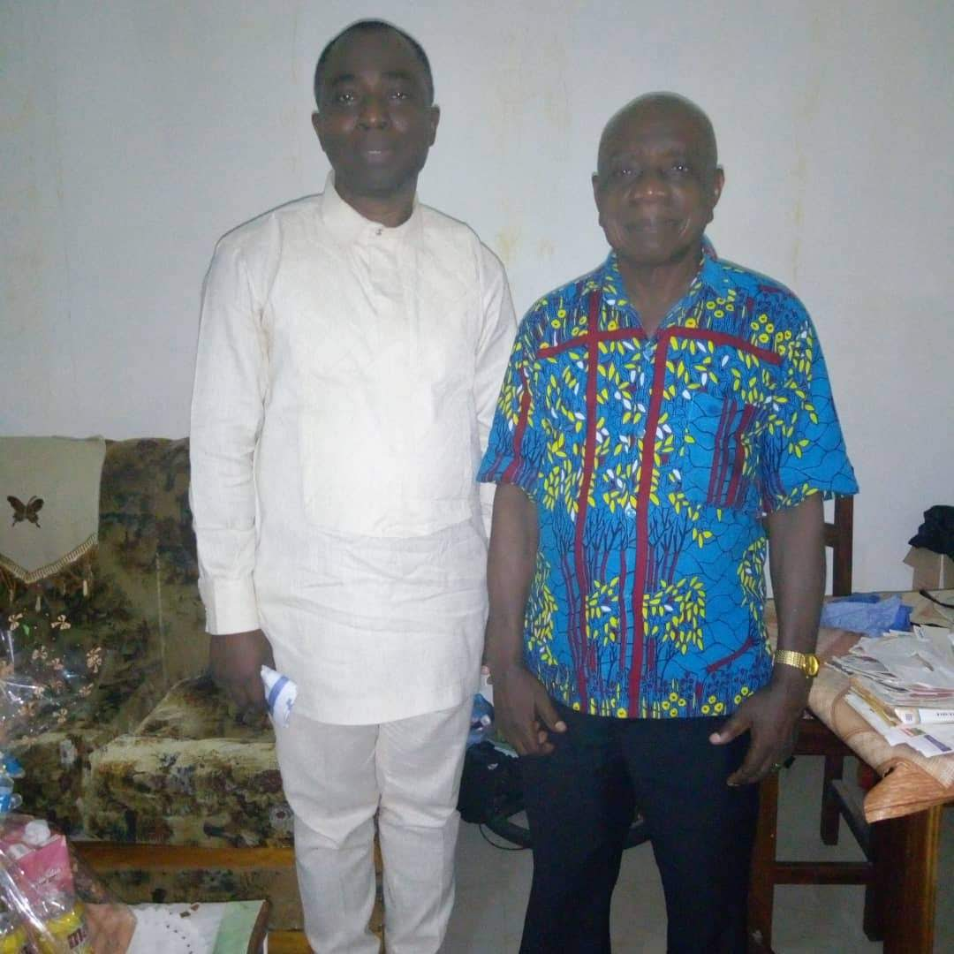
MASTER DANSO AND ANNFAM BOARD CHAIRMAN - 1ST VISIT

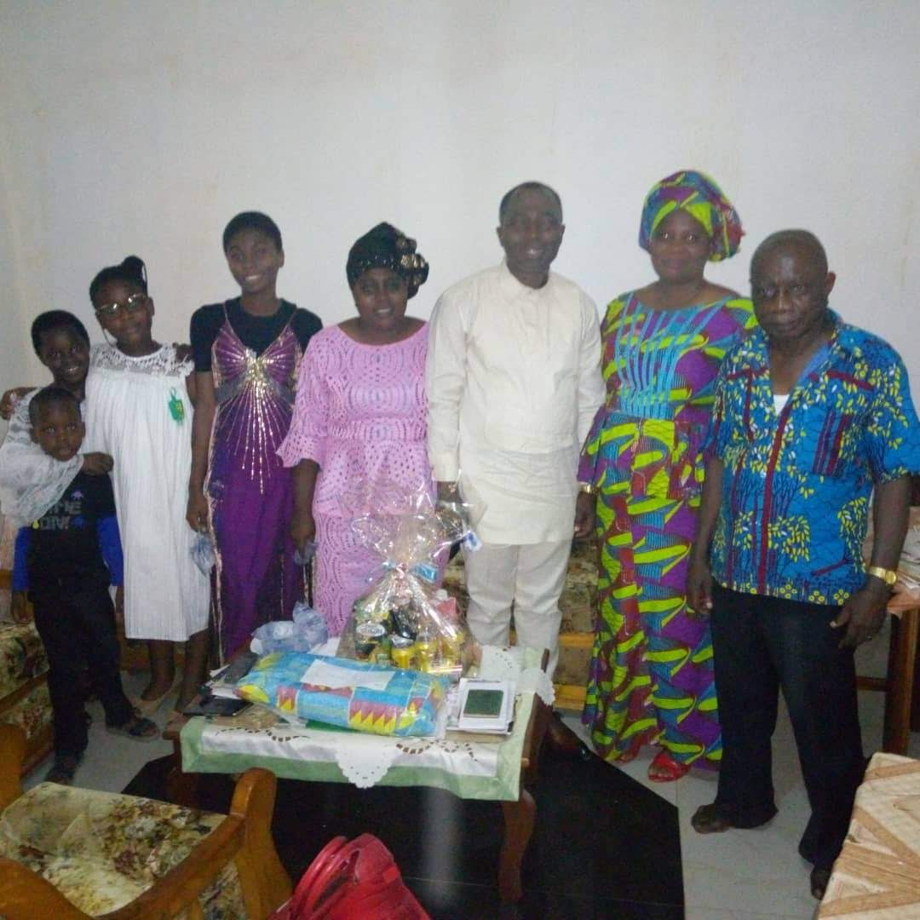
FAMILY POSE WITH MASTER DANSO AT HIS RESIDENCE
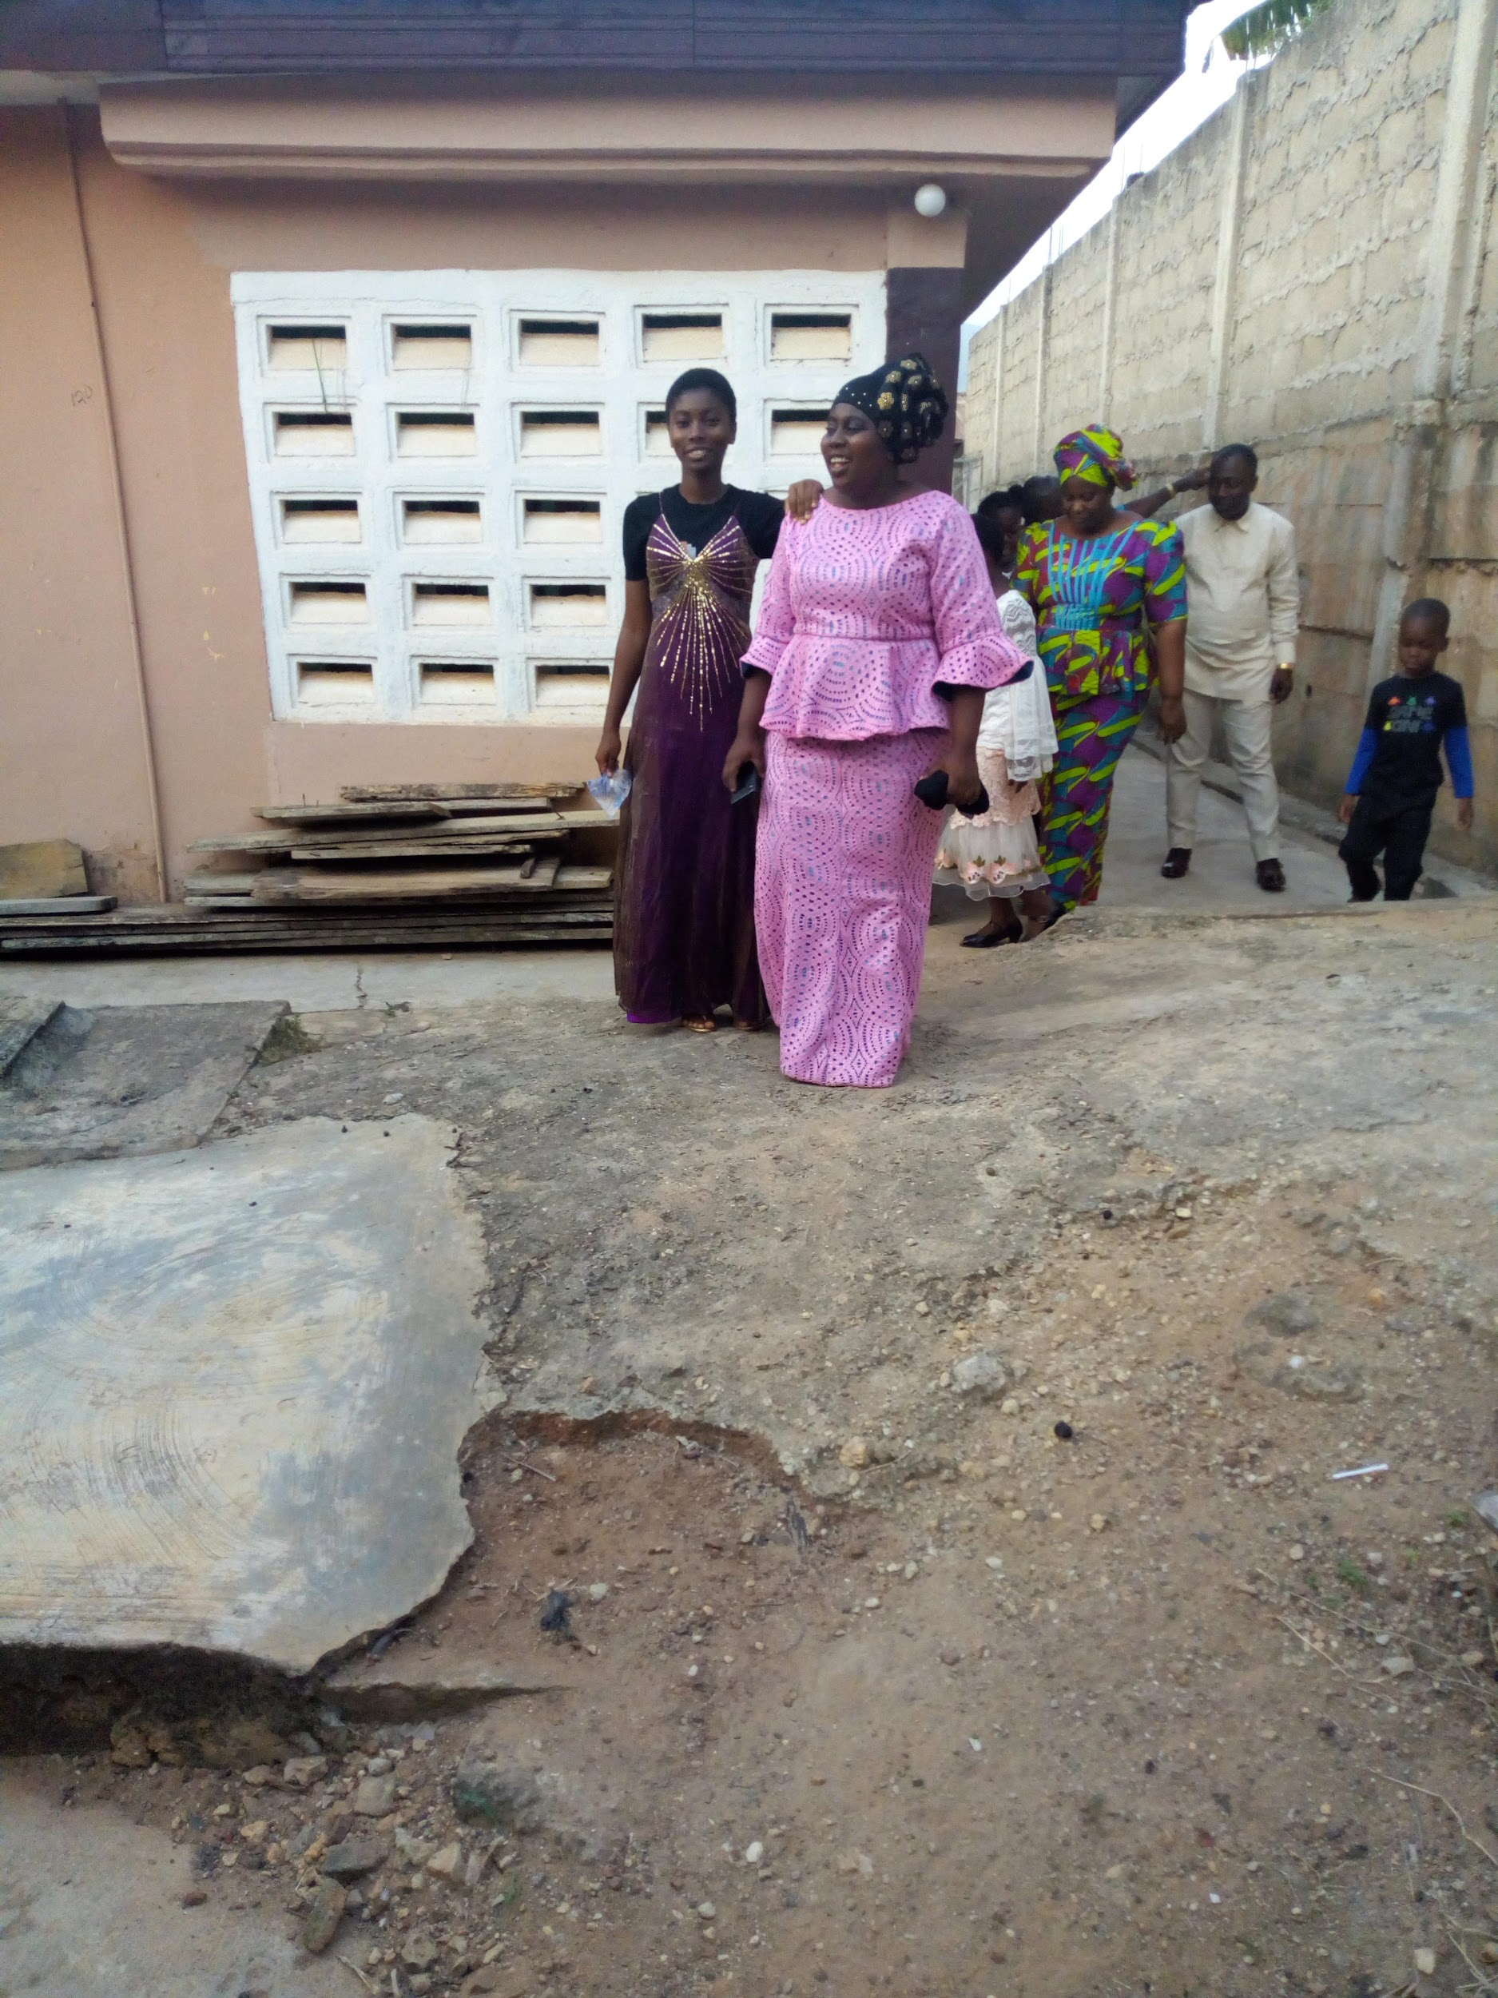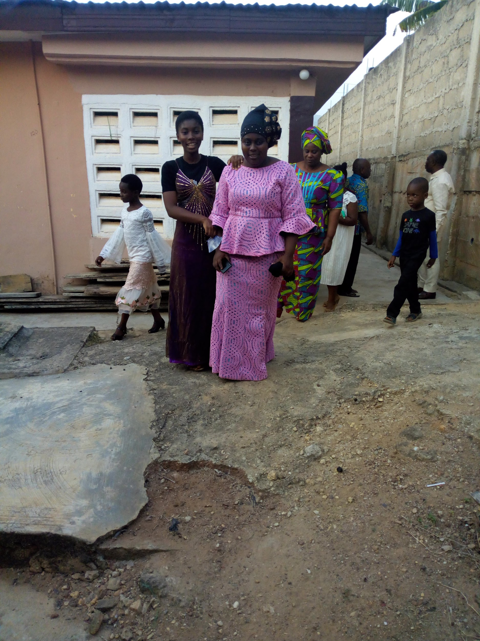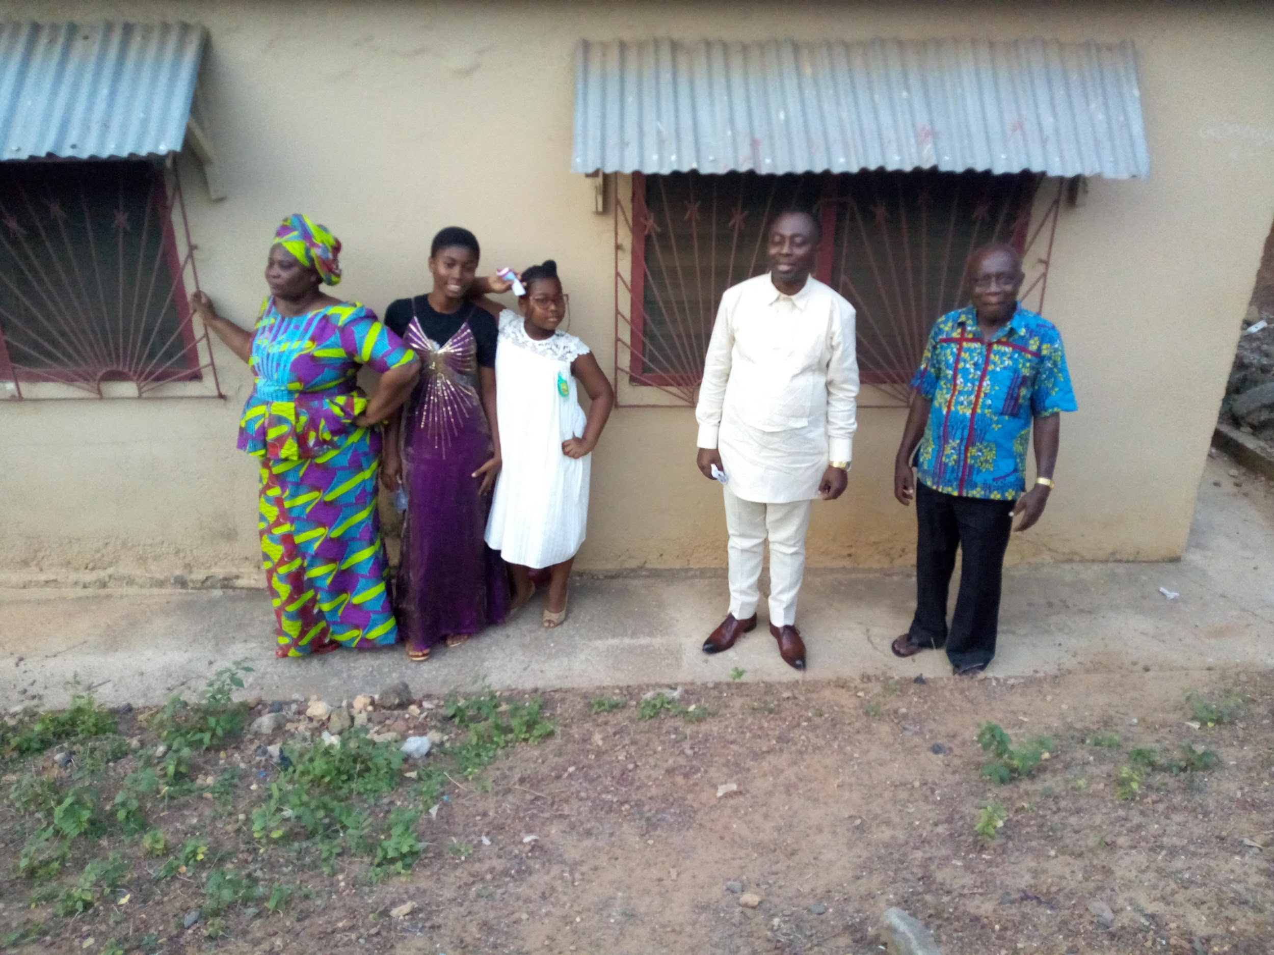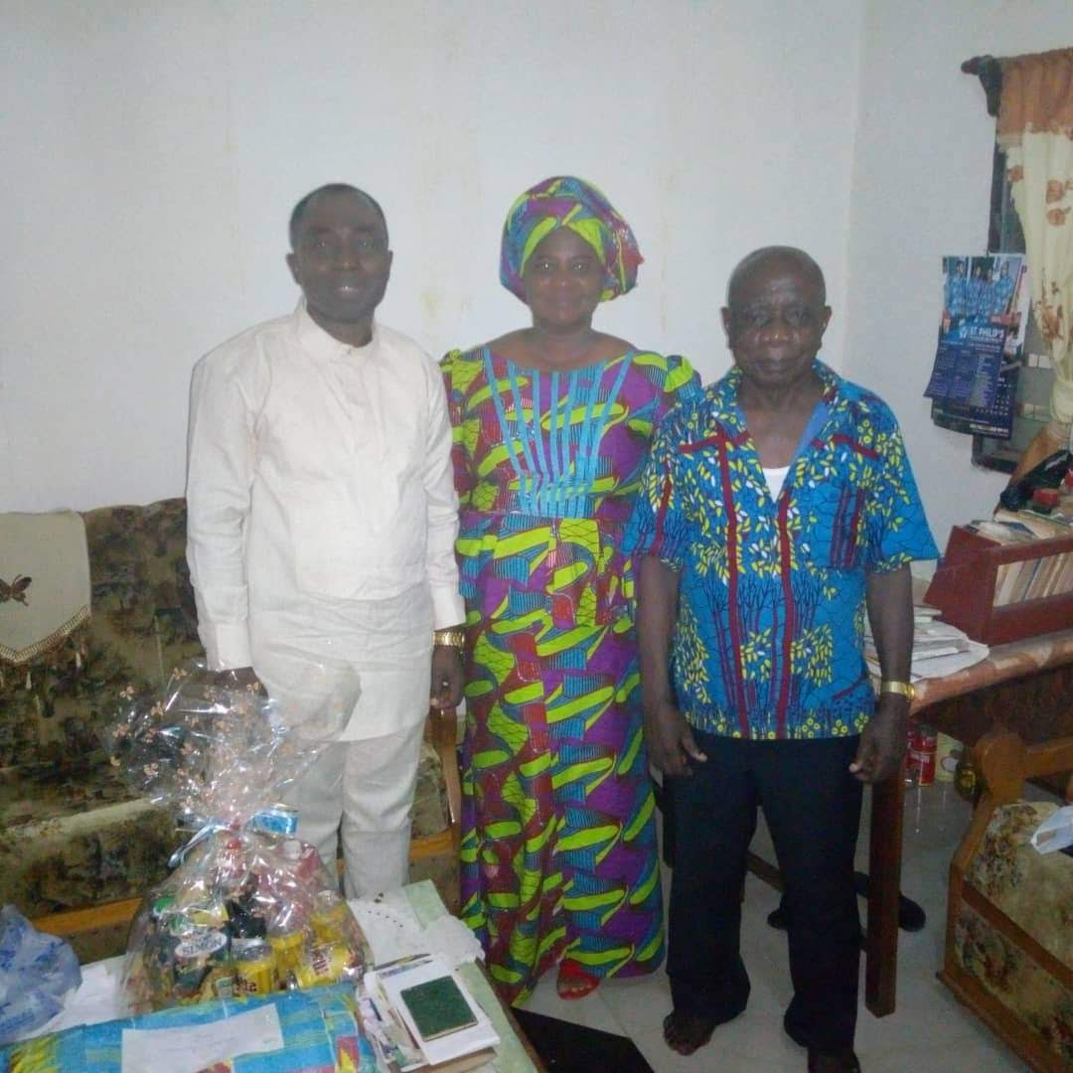
MY DEAR WIFE, MYSELF AND MASTER DANSO AT HIS RESIDENCE

PICTURE GALLERY 2

1ST VISIT TO HOLY TRINITY SCHOOL
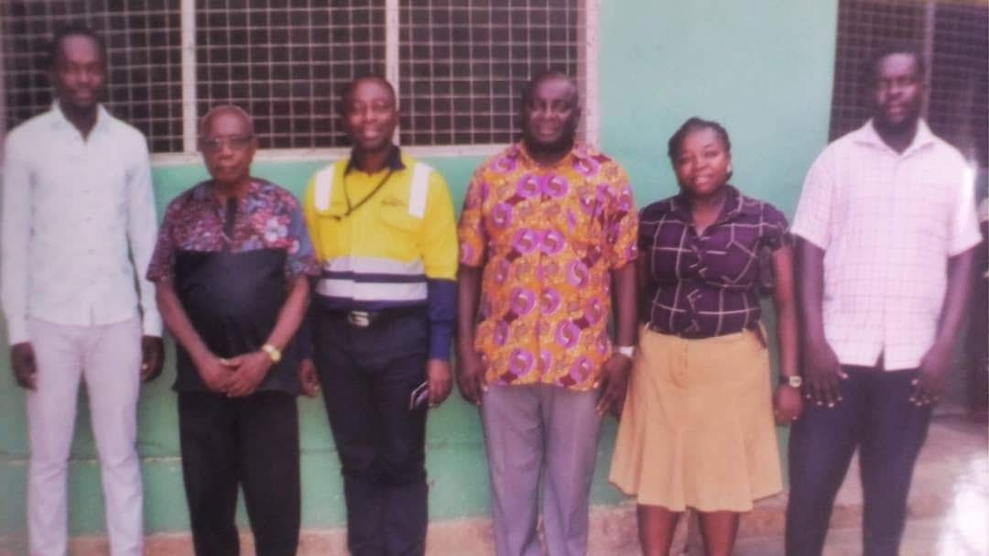
Pose With School Authorities

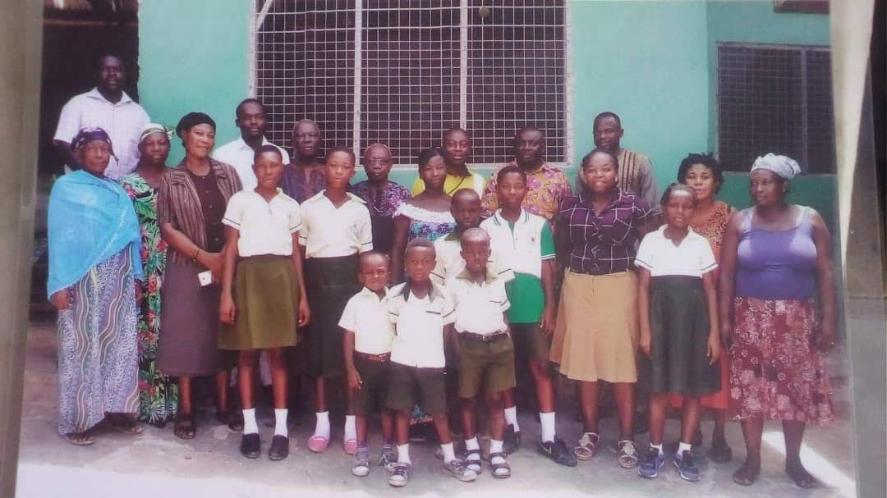
Pose With School Children (Parents and Beneficiaries Of The Scholarship Scheme)

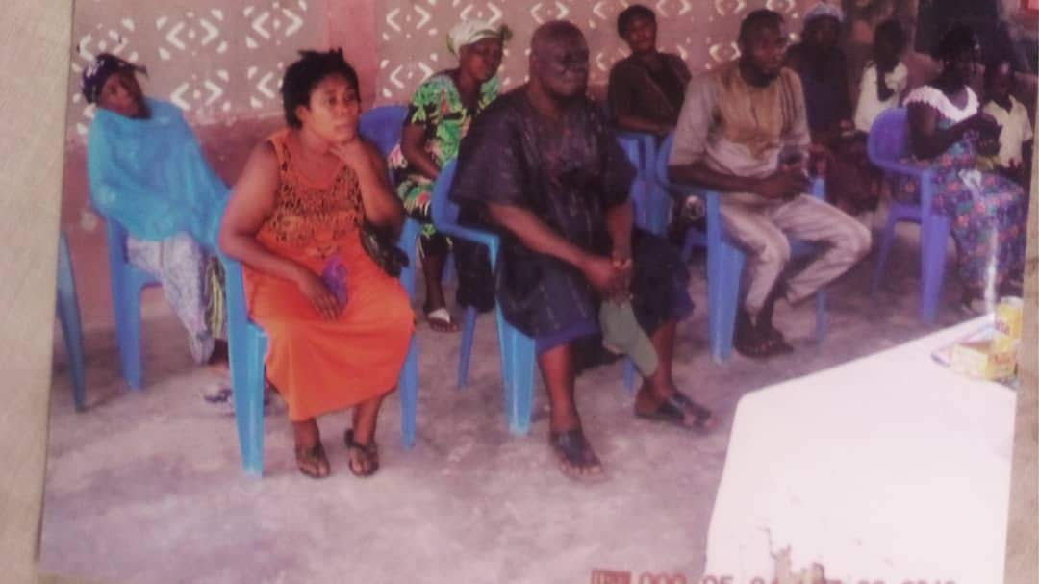
1st Meeting with Parents of Beneficiaries Of The Scholarship Scheme
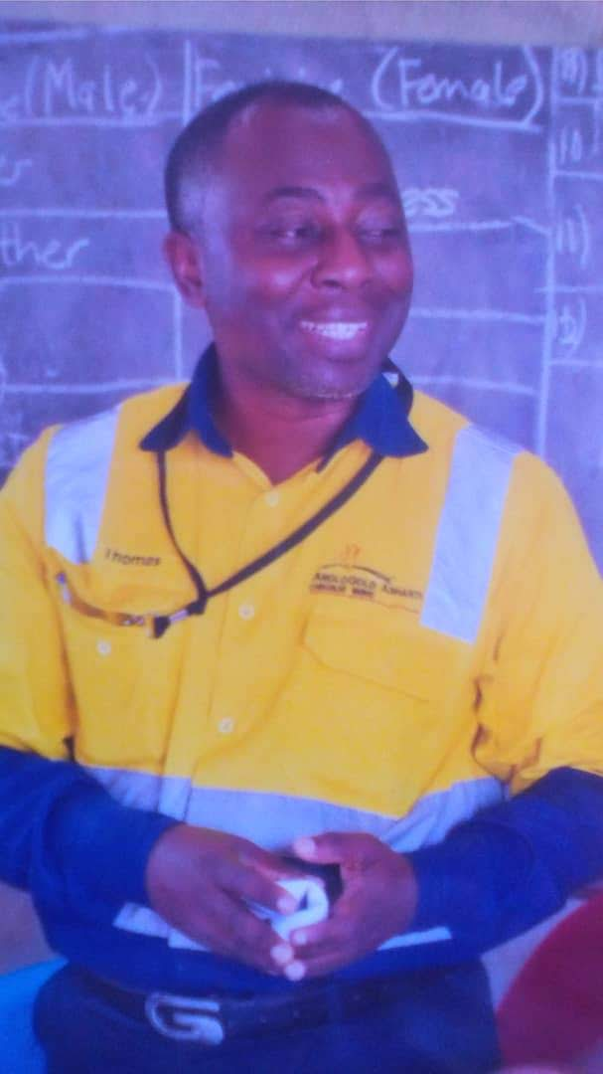
First Visit To The School
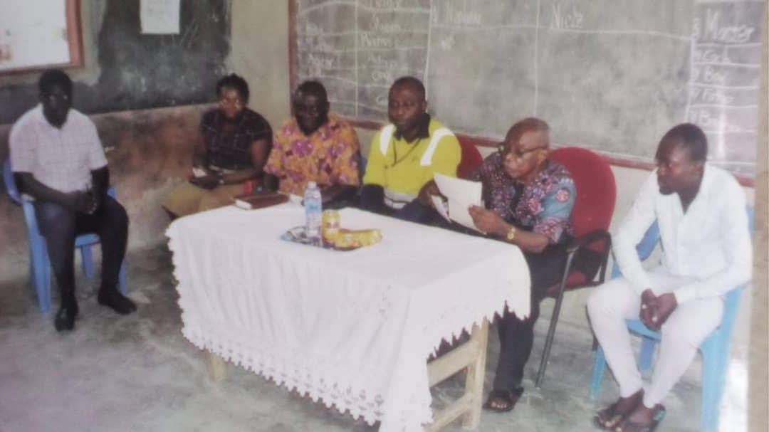
Meeting With Master Danso and Executives Of The School During 1st Visit

PICTURE GALLERY 3

VISIT BY THE CEO TO THE HOLY TRINITY SCHOOL
19TH SEPTEMBER 2023

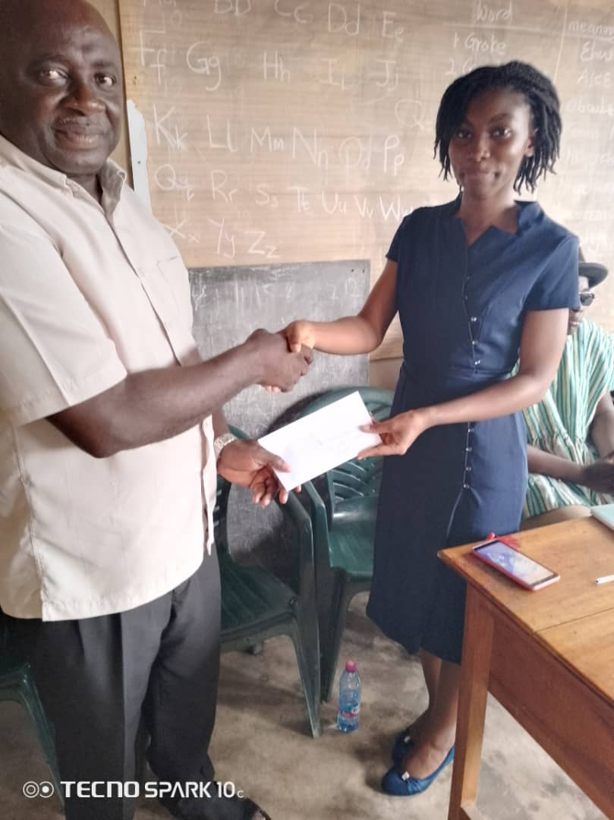
CEO PRESENTS A CHEQUE TO SCHOLARSHIP BENEFICIARIES

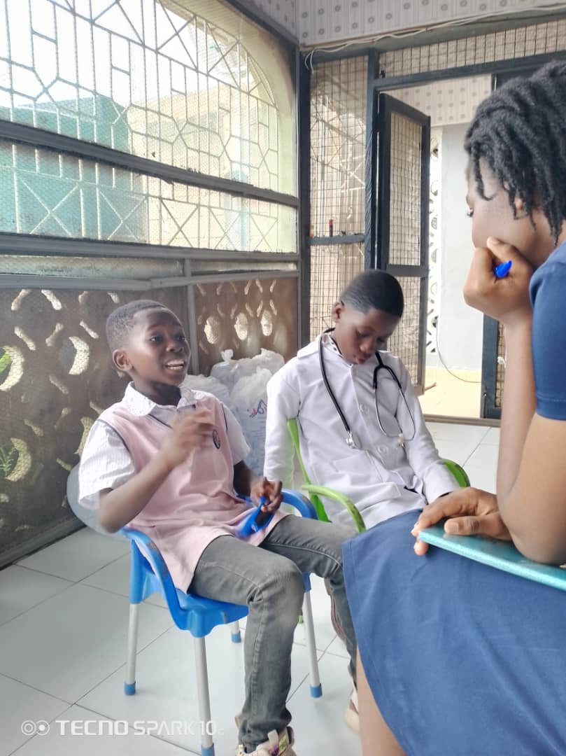
OPEN DAY - ONE ON ONE WITH PUPILS

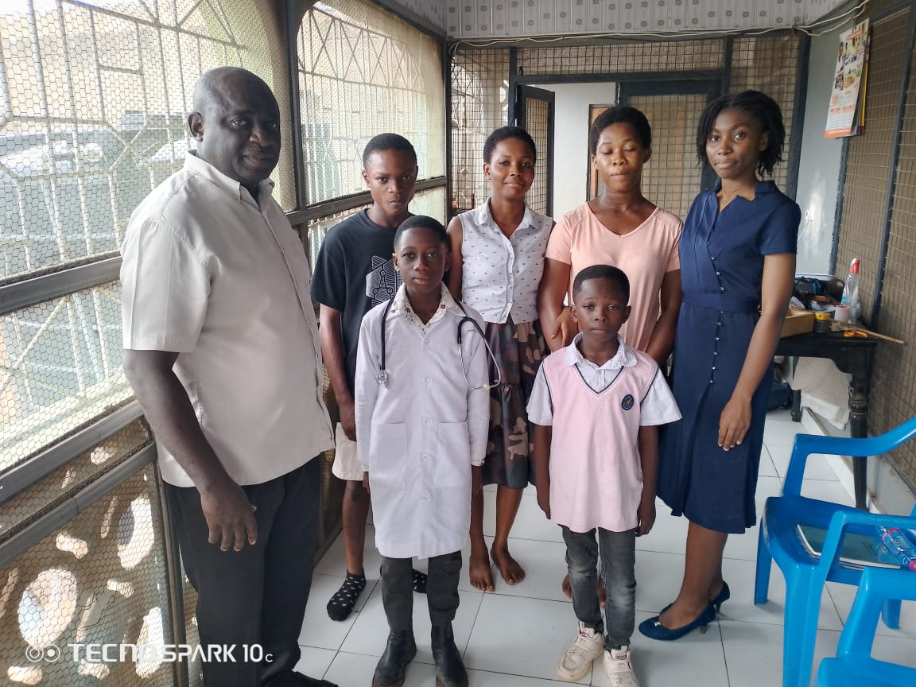
CEO POSES WITH THE DIRECTOR AND STUDENTS OF HOLY TRINITY SCHOOL

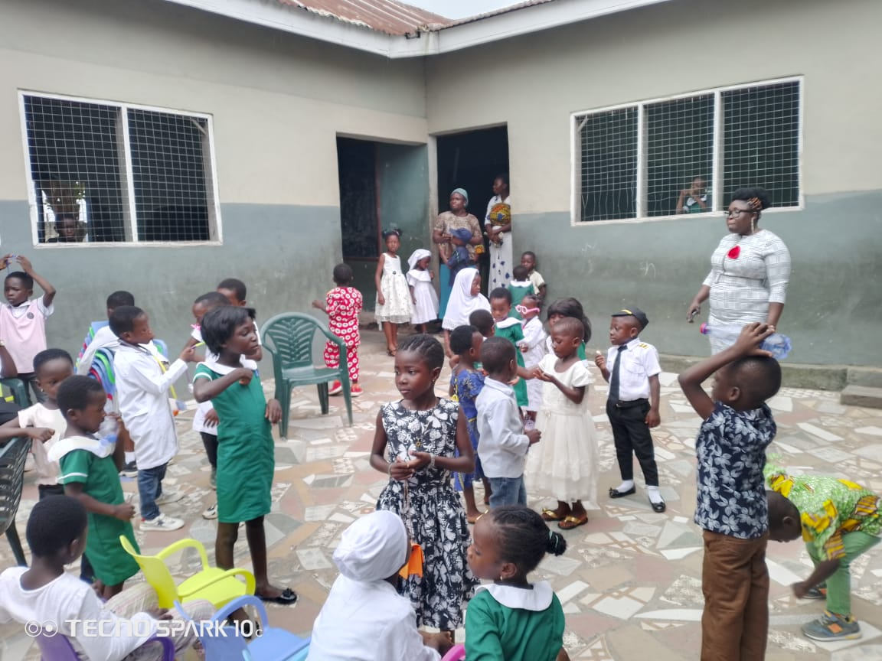
OPEN DAY AT HOLY TRINITY SCHOOL
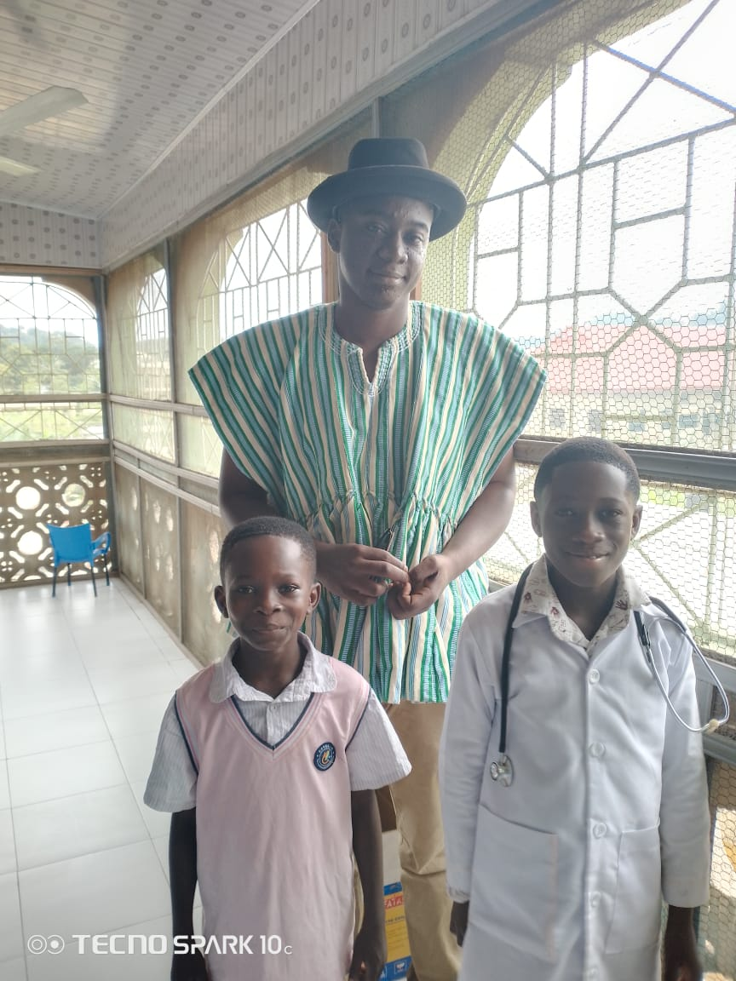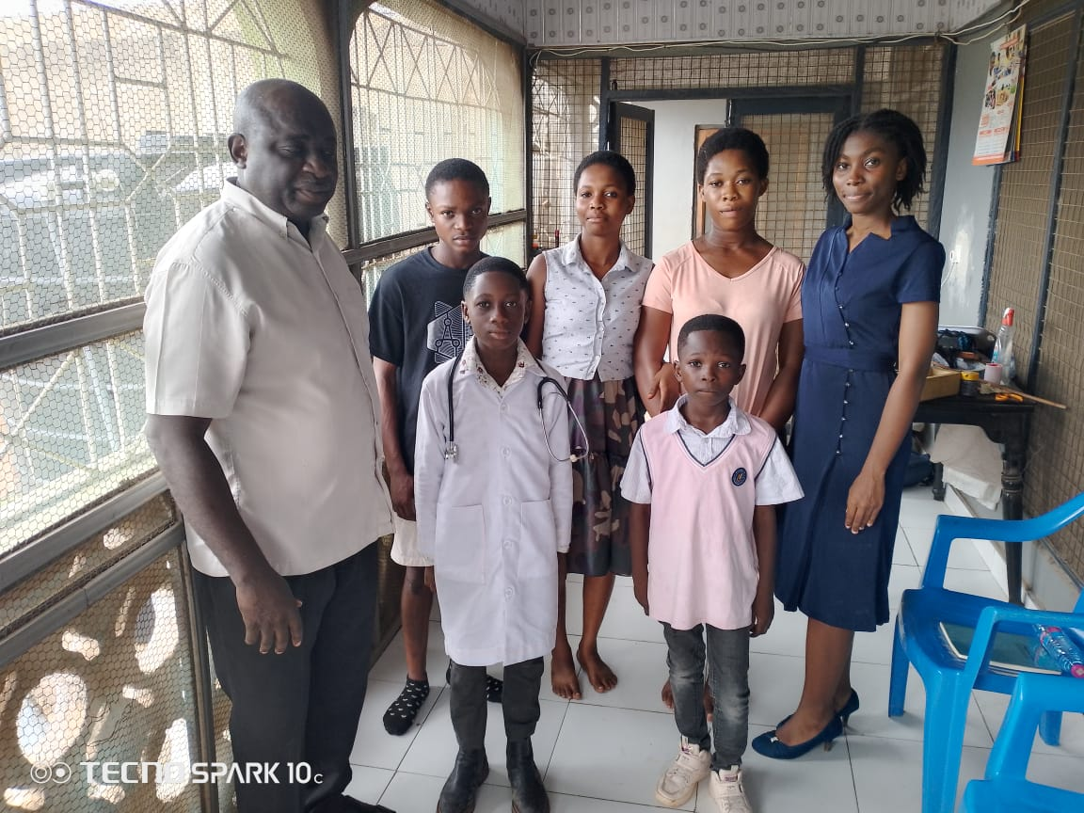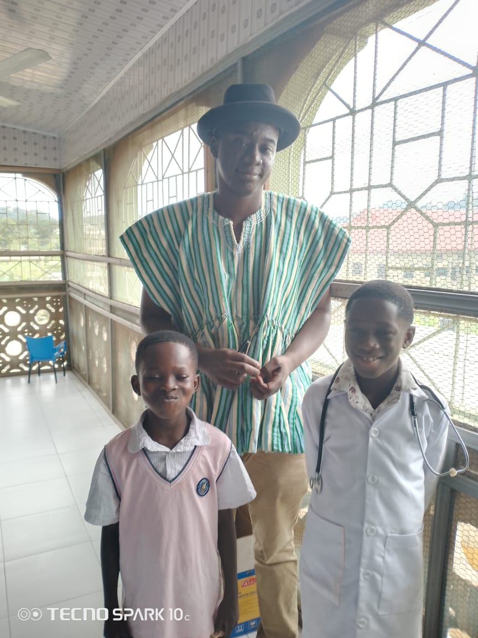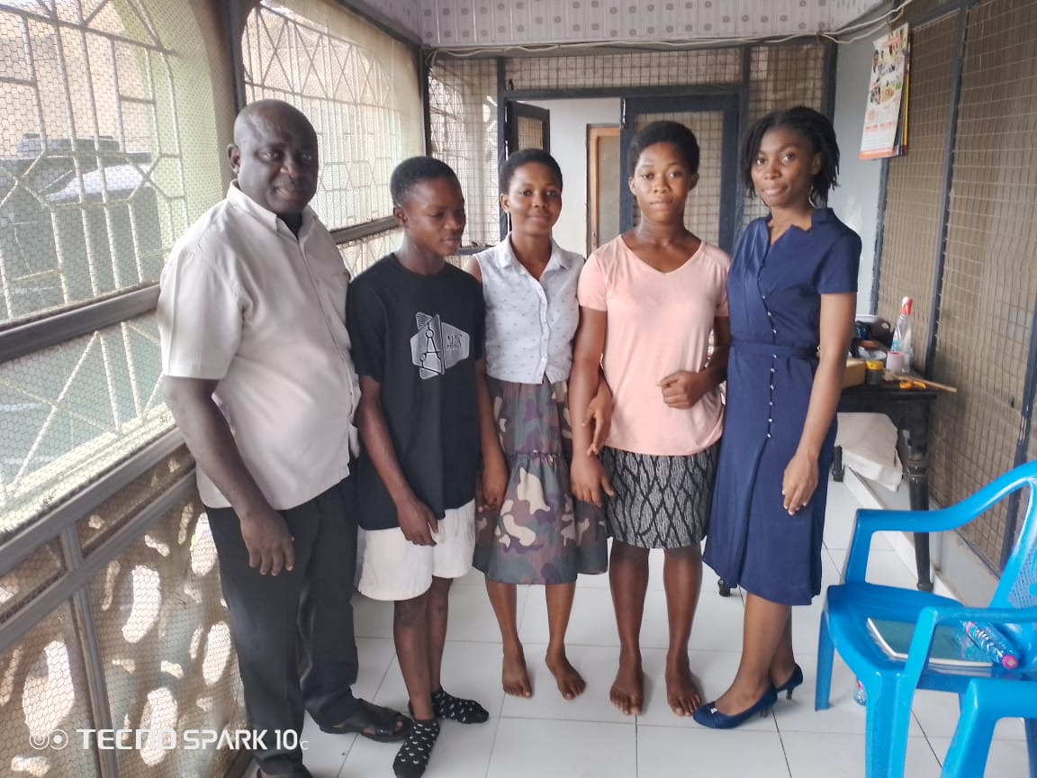
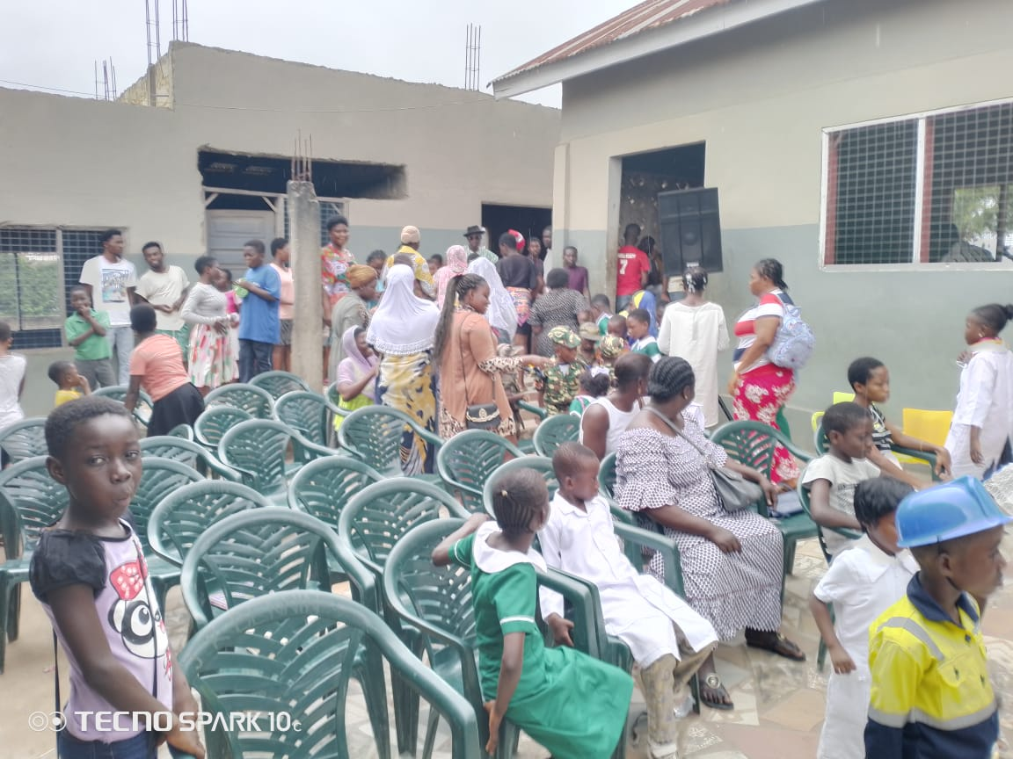
THE SCHOOL’S OPEN DAY EVENT
